This is the main window of the application. The black area is where the camera stream is displayed or the image, depending on which the user is using.

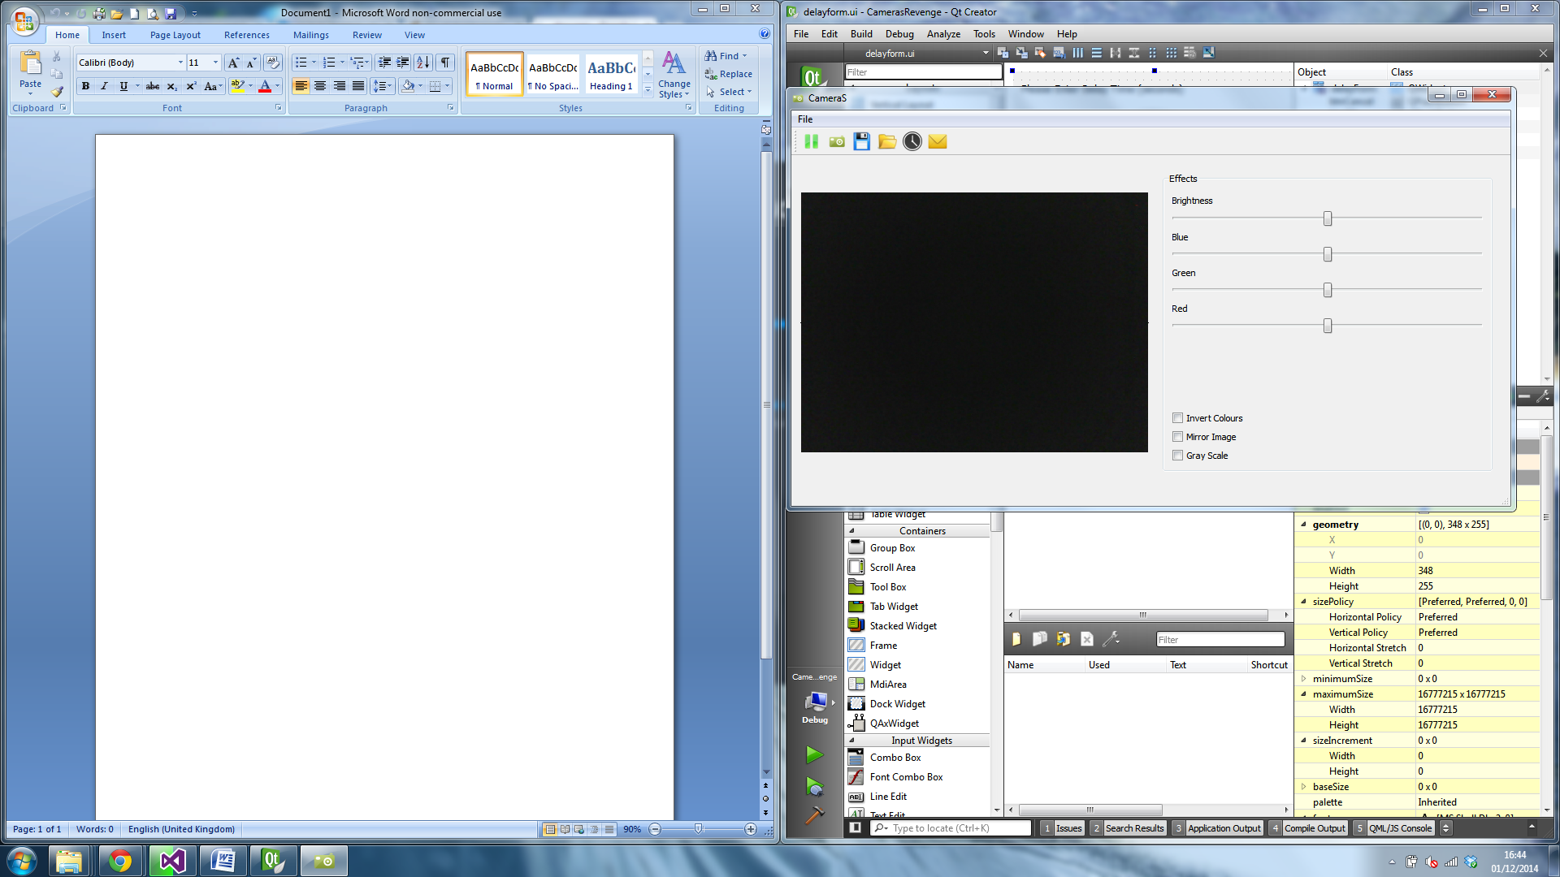

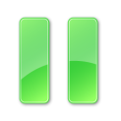 This action button stops the camera stream.

This action button starts the camera stream.

 This button captures the current frame of the stream. (CTRL+ C)

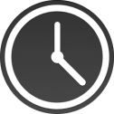This action button opens the delay widget. (CTRL+ D)

This action button opens the widget for sending emails. (CTRL+ M)

C:\Users\Jack\Google Drive\Final Year\Cross Platform\CamerasRevenge\Resource\save.pngThis button opens a save dialog to choose a location and save the current image. (CTRL+ S)

C:\Users\Jack\Google Drive\Final Year\Cross Platform\CamerasRevenge\Resource\folder_open.pngThis action button displays a file dialog which allows an image to be opened. (CTRL+ O)

The file menu button opens the drop down menu seen below.

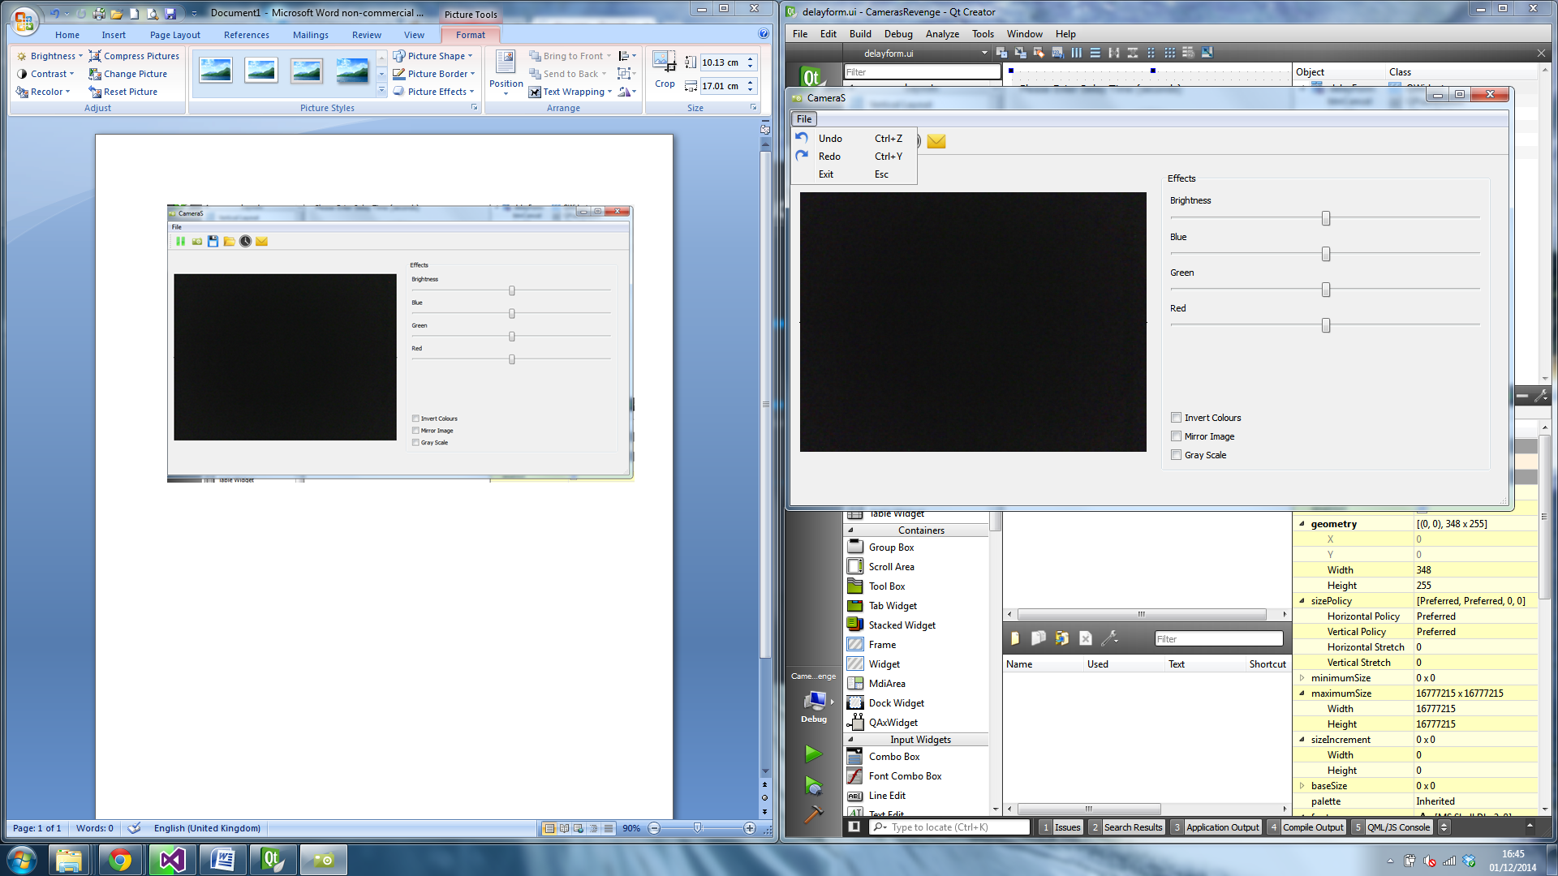

The Exit button closes the application (ESC).

Undo undoes the last change to the image that has been edited (CTRL+ Z)

Redo redoes the last change to the image (CTRL + Y)

The form below is displayed when the Mail action is triggered.

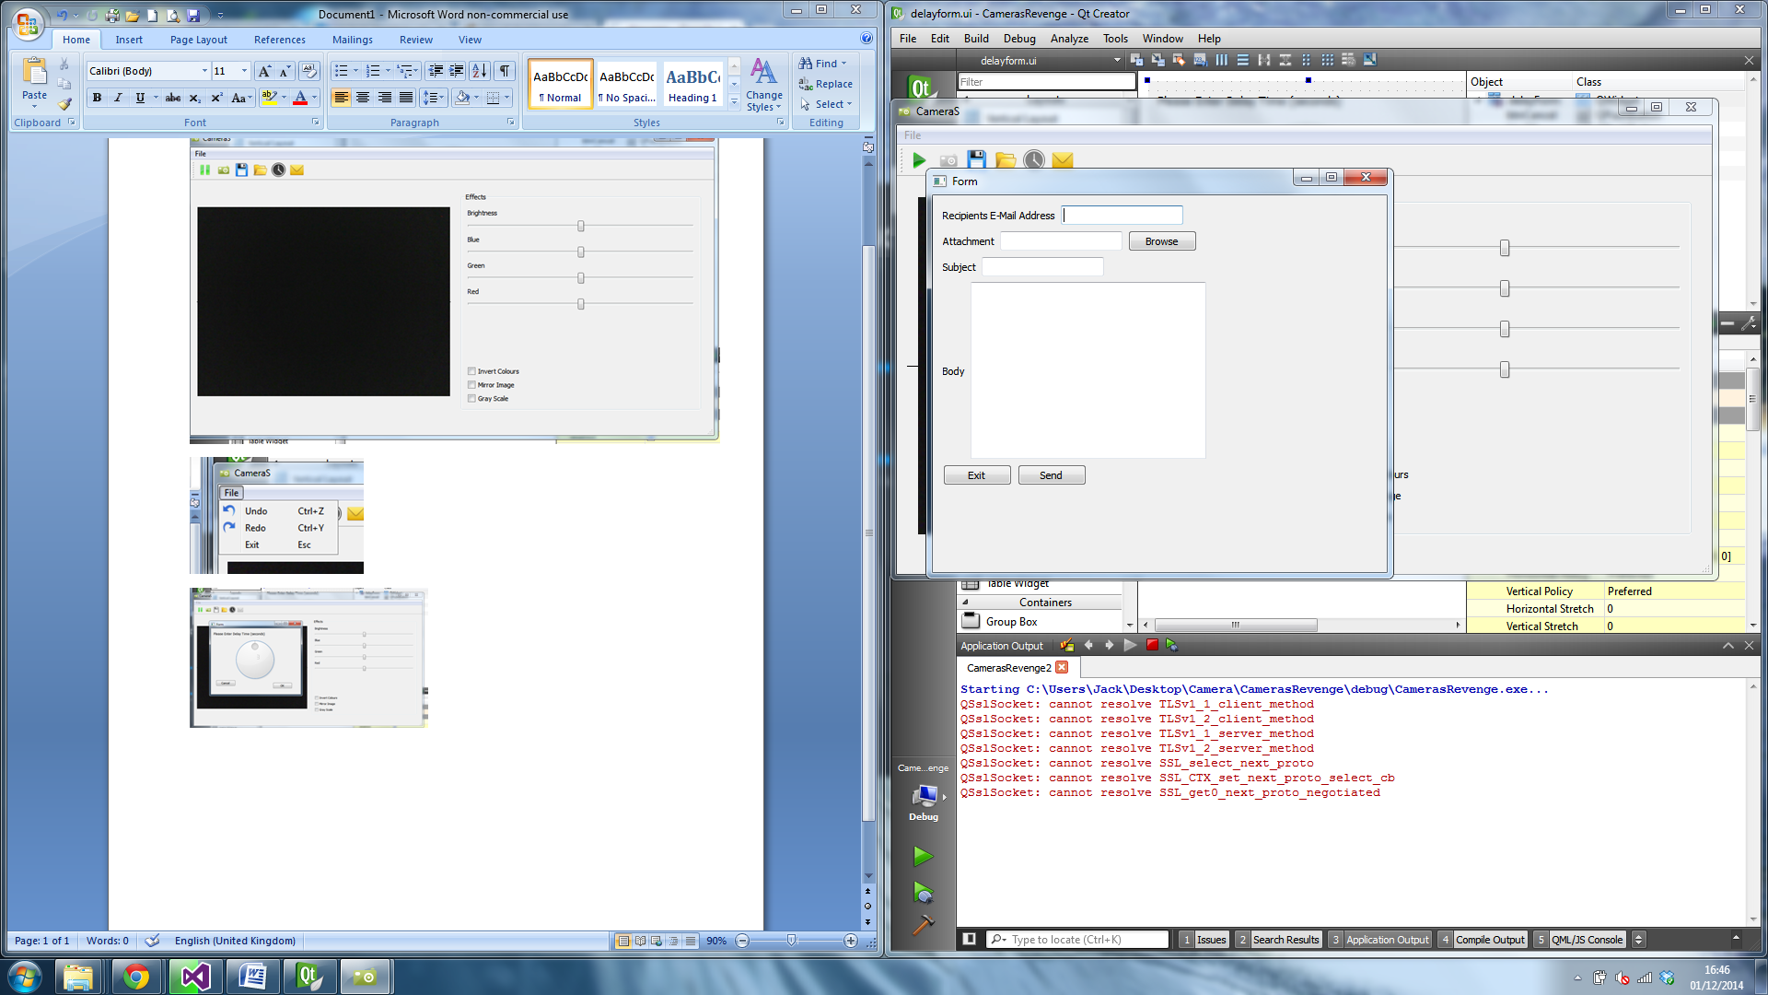

Recipients email text box is for the intended receiver of the email using ; to separate multiple contacts.

The browse button opens a file dialog to select a file to be attached to the email, multiple files can be sent.

Subject is for the email subject and body is for the contents of the email.

Exit closes the form and if all text boxes are filled out correctly send will send the email.

This widget appears when the delay action is triggered.

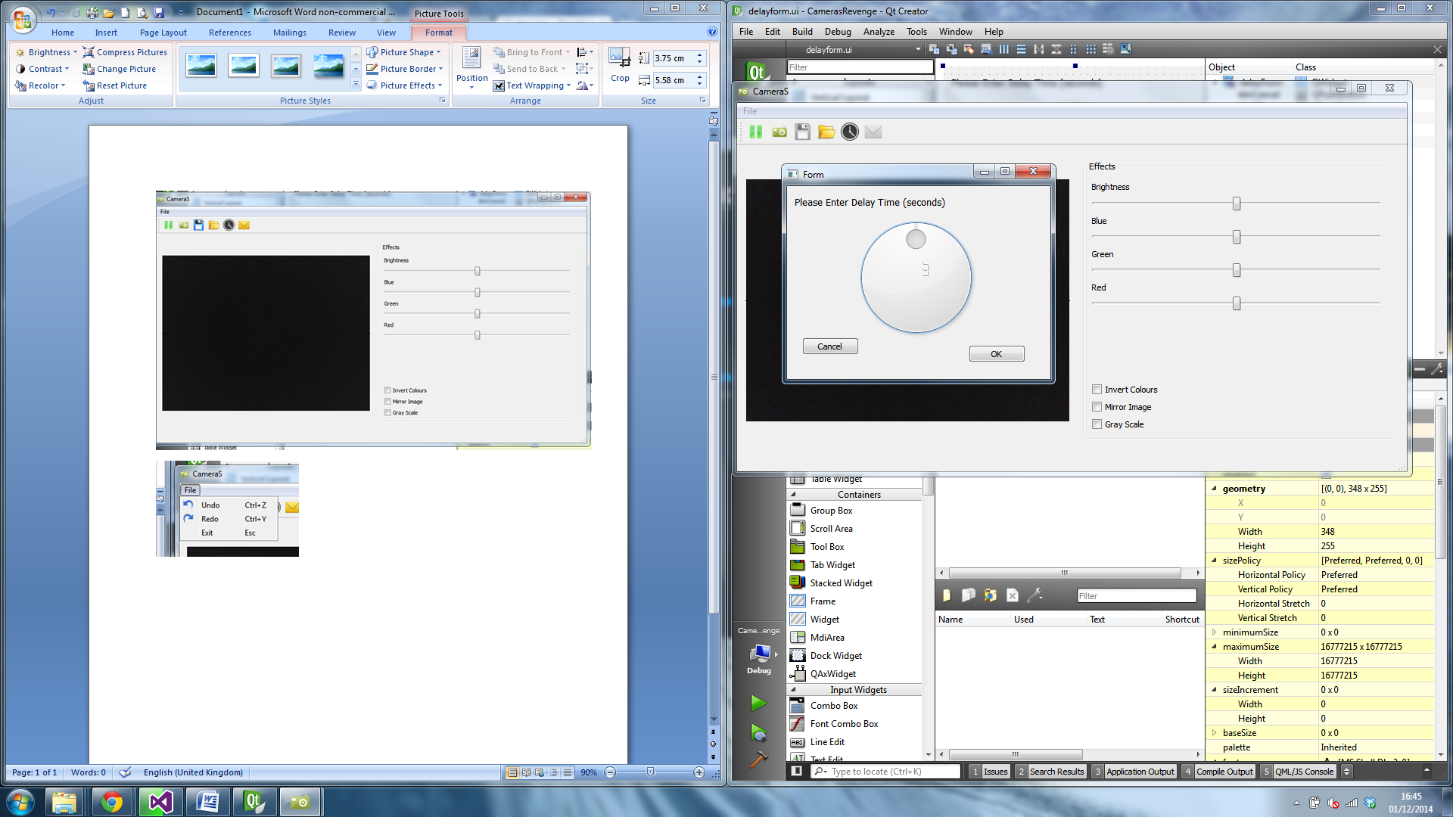

The centre dial widget can toggle from 0-5 seconds which is displayed in the middle of the dial. When ok is selected the widget closes, emits a signal and a picture will be taken in that amount of time.

Cancel closes the widget.

The tools on the right hand side of the main widget affect the image being displayed on the left.



The four sliders have values between -50 and 50. Each alters the contrast of the image as the label above states.

The invert colours check box can be toggled to invert the RGB values of the image.

The mirror image check box flips the image horizontally and can also be toggled

The gray scale check box converts the image to gray scale, this can’t be toggled from on and off but can be undone.